DFSC 4317 - Information Security
Assignment 5
Instructor: Dr. Cihan Varol, cvarol@shsu.edu
40 Points in Total

Question 1 (20 points): Examining Suspicious Links Using Online Resources (Virustotal, Urlscan or PhishTank)
There are online resources that scan any suspect link using static malware analysis processes and provide automated results for easy identification of any malicious component links.
Overview of the Lab
Organization: Lone Star Research Institute
Department: HR & Payroll
Employee Involved: Maria Thompson, Payroll Specialist
Incident Date: Tuesday, 10:14 AM
Maria reports receiving an unexpected email claiming her “direct deposit information needs immediate verification to avoid payroll delays.” The email appears to come from the HR department but contains several red flags.
She forwards the message to the internal security team for investigation.
The Email
From: HR Support
To: Maria Thompson
Subject: Urgent: Action Required to Avoid Payroll Interruption
Body:
Dear Employee,
Our system detected an issue with your direct deposit information.
Please verify your details immediately to avoid interruption of your upcoming paycheck:
https://app.e-paylinks.com
Failure to act within 24 hours may result in delayed payment.
Thank you,
HR Support Team
Maria notes that the domain looks “almost right” but not exactly the same as the official one she remembers.

Your Tasks (shown screenshots of your work)
- Is the link malicious? Yes
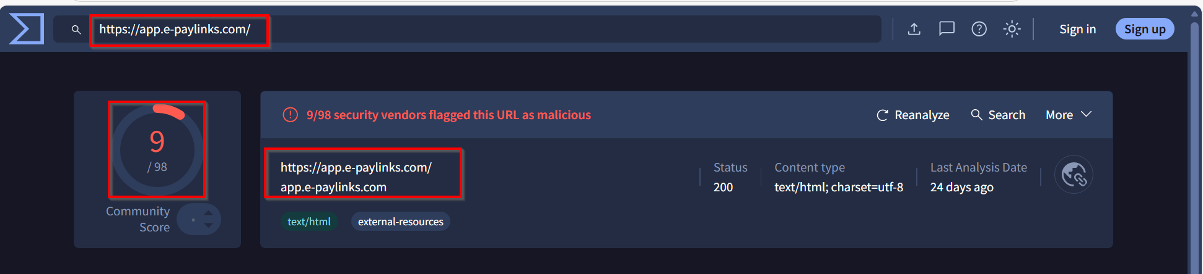
My Screenshots of Work
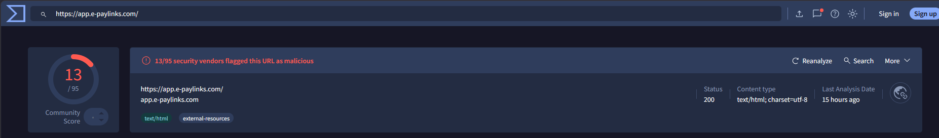
Answer: Yes, based on the security analysis, the link https://app.e-paylinks.com is malicious. According to the automated results from VirusTotal, multiple security vendors have flagged the URL as a threat.
- If it is malicious, how many security vendors flagged it as a malware and a phishing link?
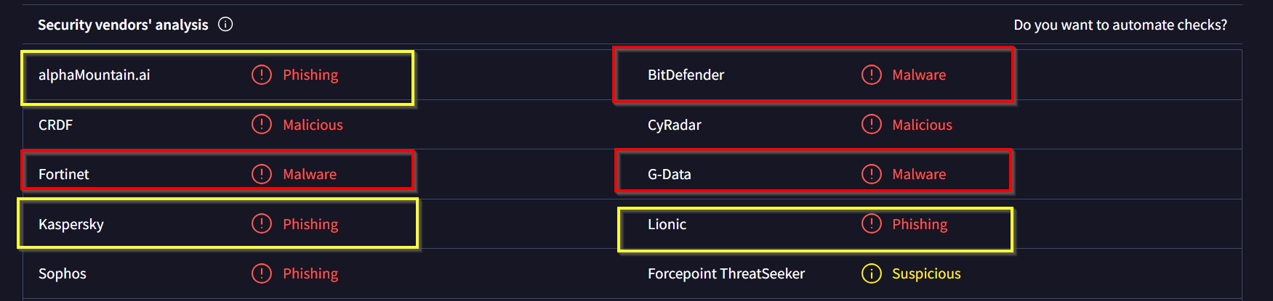
My Screenshots of Work
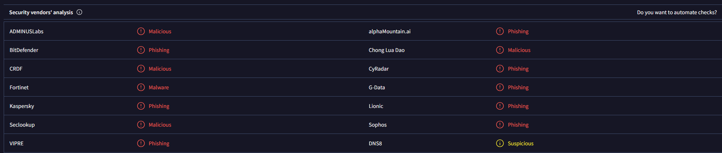
Answer: Yes, the link is malicious. Based on the security vendors' analysis, 1 vendor flagged it as malware and 8 vendors flagged it as phishing.
- Malware (1): Fortinet.
- Phishing (8): alphaMountain.ai, BitDefender, CyRadar, G-Data, Kaspersky, Lionic, Sophos, and VIPRE.
There are 9 detections total in those specific categories.
- If it is not malicious, how many security vendors flagged it as clean or suspicious?
It is malicious but some security vendors flagged it as clean and suspicious.
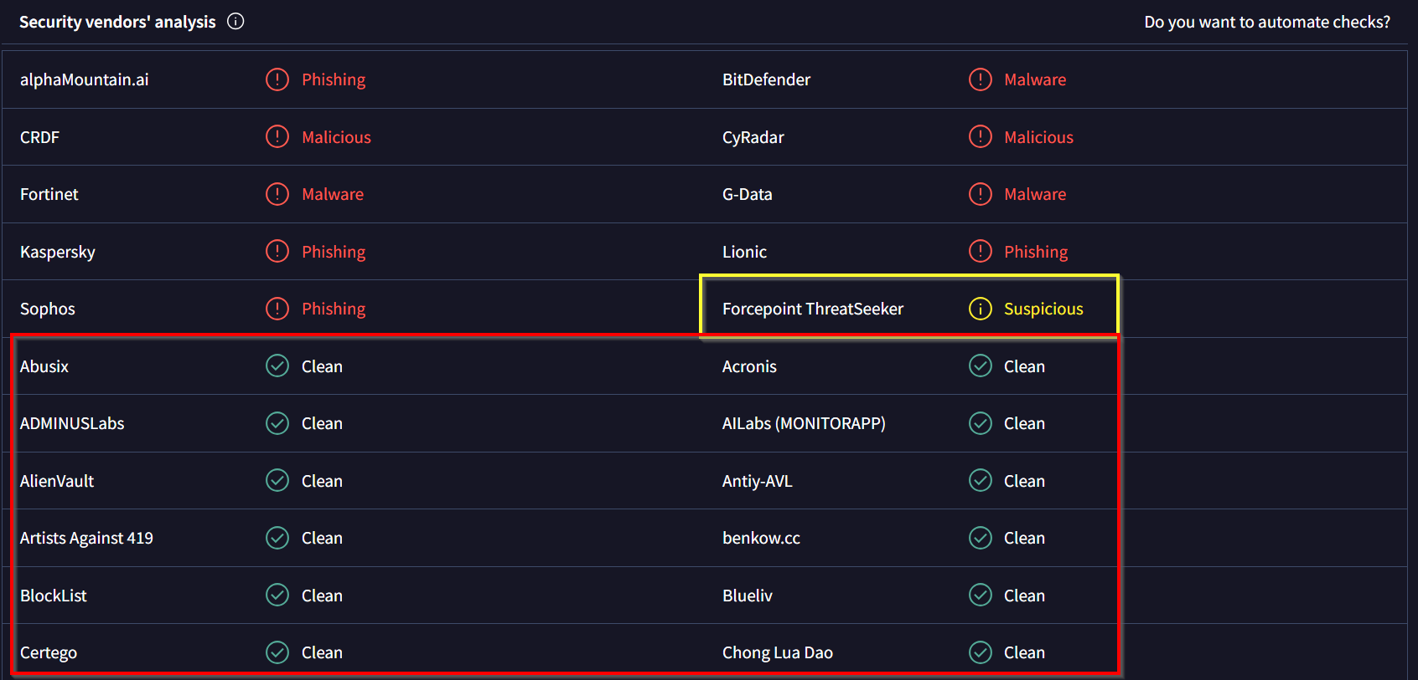
My Screenshots of Work
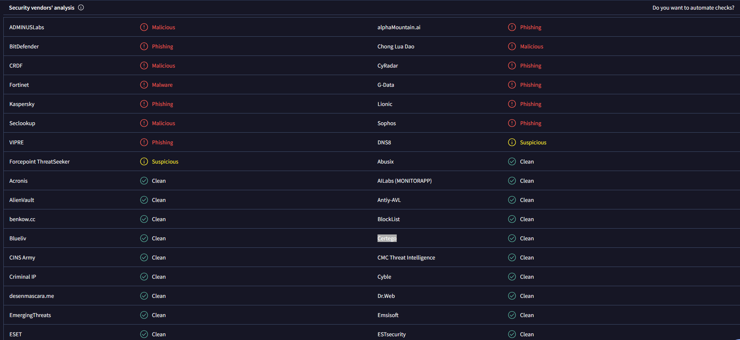
Answer: Although the link is malicious, several vendors did not detect it yet. Based on the security vendors' analysis:
- Clean: 82 security vendors flagged the link as clean (highlighted in the red box).
- Suspicious: 2 security vendors flagged the link as suspicious (highlighted in the yellow box). The two suspicious vendors are DNS8 and Forcepoint ThreatSeeker.
This discrepancy occurs because different security engines use different detection methods, and there is often a detection lag before a new malicious link is added to every database.

- It is malicious but some security vendors flagged it as clean and suspicious, why? Briefly explain.
Answer: A link can be malicious even if some VirusTotal vendors mark it clean because many engines rely on reputation, signatures, or known patterns. If the domain is new, uses cloaking, shows benign content to scanners, or the attack only appears after user interaction, some vendors won’t detect it yet. VirusTotal is not real-time threat intel, so detection lag is normal.

My Answer: The link is malicious, but detection results vary because security vendors do not update their databases in real-time. While 13 vendors identified a threat, 82 engines flagged it as clean (highlighted in the red box) and 2 flagged it as suspicious (highlighted in the yellow box). This discrepancy occurs because different vendors use different detection methods—such as static, reputation-based, or behavioral analysis—and newer malicious links often experience a "detection lag" before being recognized by all engines.

- What is the first date and time this this was detected malicious on the internet?
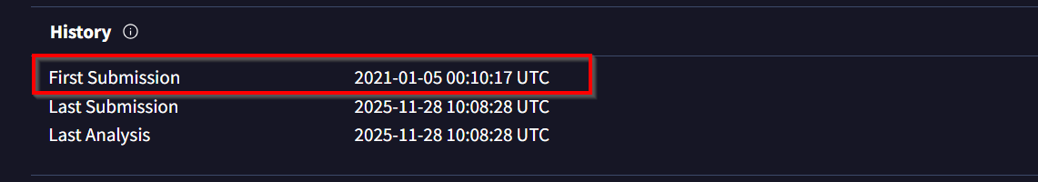
My Screenshots of Work
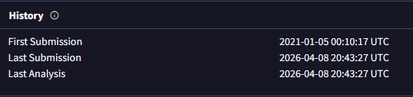
Answer: The link was first detected malicious on the internet on 2021-01-05 at 00:10:17 UTC.

- What is the serving IP address of this link?
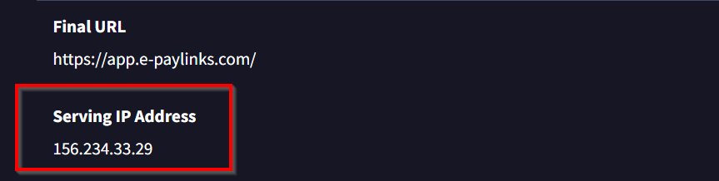
My Screenshots of Work
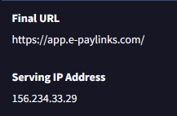
Answer: The serving IP address of this link is 156.234.33.29

- What is the fingerprint of this link?
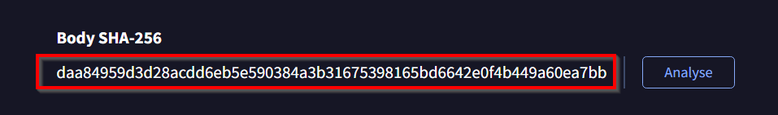
My Screenshots of Work
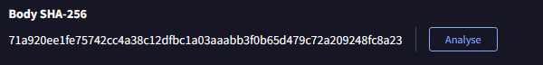
Answer: The fingerprint of this link is represented by its cryptographic hash. According to the Details tab under the Body SHA-256 section, the fingerprint is: 71a920ee1fe75742cc4a38c12dfbc1a03aaabb3f0b65d479c72a209248fc8a23
- Does this link lead to file? Give any hints you find.
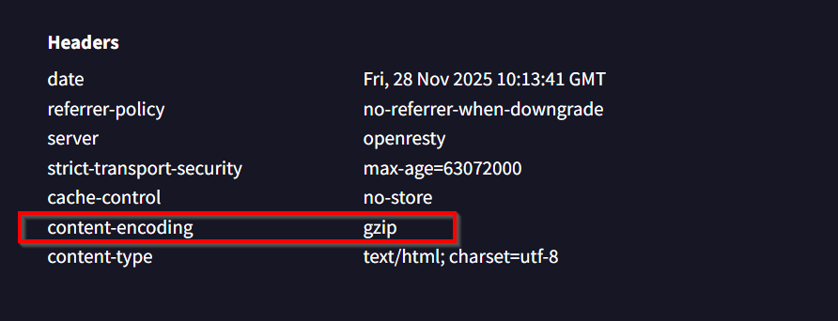
My Screenshots of Work
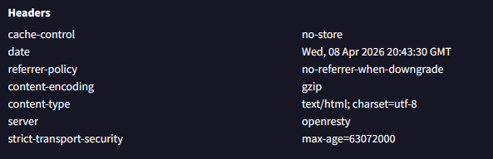
Answer: No, the link does not lead directly to a downloadable file. According to the Headers in the screenshot, the content-type is listed as text/html, which confirms the server is delivering a webpage rather than a binary file (like an .exe). Additionally, the content-encoding of gzip (highlighted in the red box) is a standard method for compressing web content for browser delivery.

- As a digital security expert, you have a database of links provided by your boss. Check whether this link is known to any of your databases. Provide database name and screenshot.
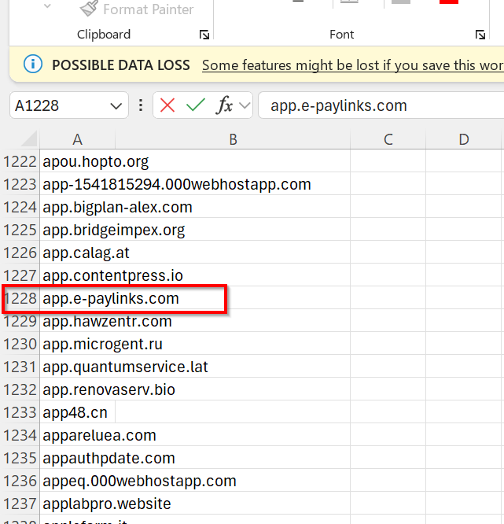
My Screenshots of Work
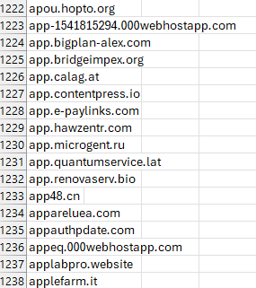
Answer: Yes, the link is known to our internal database. I cross-referenced the URL app.e-paylinks.com against the provided links list and successfully located it in the records.
- Database Name: Internal Malicious Links Database (Excel provided by Supervisor).
- Location: Row 1228 (as highlighted in the red box in my screenshot).

- Also, your boss provided you with some additional links submitted by your colleague. Verify whether they are also present in any of your database. Provide database name and screenshot.
Database Name: Internal Malicious Links Database (Source: NETAPI.COM).
- information-help-account.com
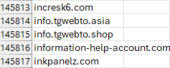
Answer: information-help-account.com: Status: Present. Found at Row 145816 (as shown in my screenshot).
- vfrtgbnhym.vercel.app
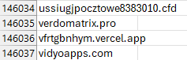
Answer: vfrtgbnhym.vercel.app: Status: Present. Found at Row 146036 (as shown in my screenshot).
- 000000login.weebly.com (Not Present)
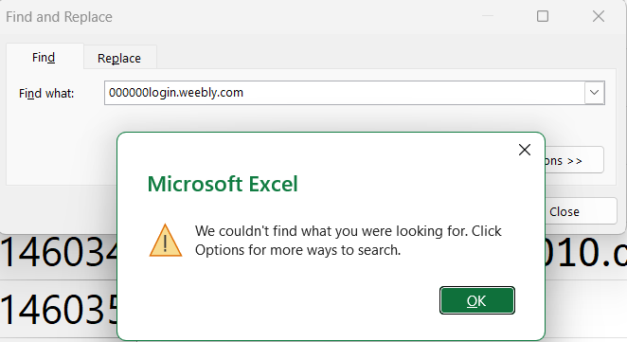
Answer: 000000login.weebly.com: Status: Not Present.
- %20mandrillapp.com (Not Present)
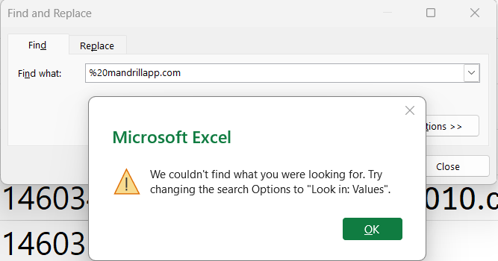
Answer: %20mandrillapp.com: Status: Not Present.
- http://eve292929.dothome.co.xn--kr/1122/?sec=susan%20r12nisch-wtb10mtz32d (Not Present)
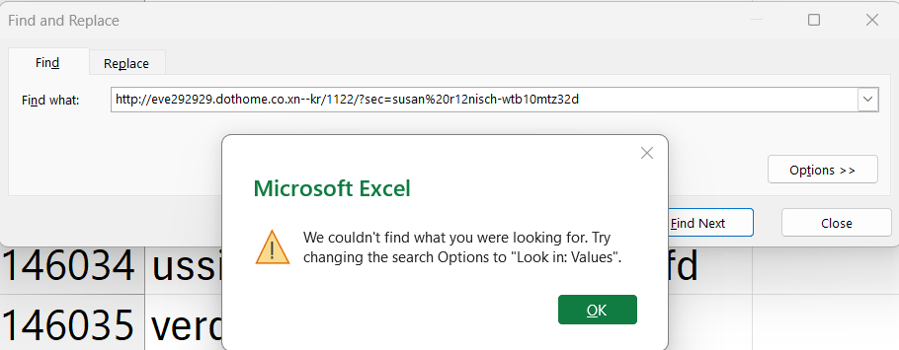
- Answer: http://eve292929.dothome.co.xn--kr/1122/?sec=susan%20r12nisch-wtb10mtz32d : Status: Not Present.

Question 2 (20 points): Demonstrate usage of Burp Suite for a task that you choose it for. This can be a payload attack or any other lab that you can do on portswigger.net. Share necessary textual and screenshot information of the goal/process/result.
Goal: To demonstrate how to use Burp Suite to perform a Reflected Cross-Site Scripting (XSS) attack on a vulnerable web application.

Step 1: Access Web Security Academy
Go to portswigger.net, select the Web Security Academy, and choose the "Reflected XSS into HTML context with nothing encoded" lab.
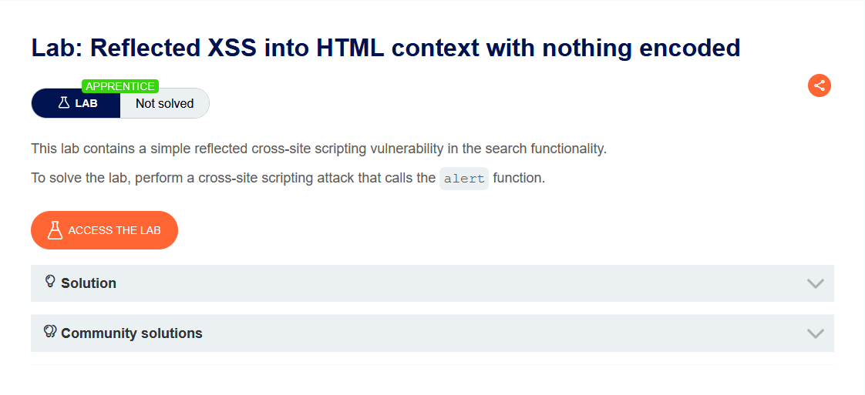
Answer: This environment provides a controlled lab setting to test how a server processes unsensitized user input.

Step 2: Launch Burp Suite
Open Burp Suite and toggle "Intercept is ON" in the Proxy tab.
Answer: I enabled Intercept so that I can catch and inspect the HTTP request before it reaches the server.

Step 3: Configure Browser Proxy
Set the browser's network settings to route traffic through 127.0.0.1 on port 8080.
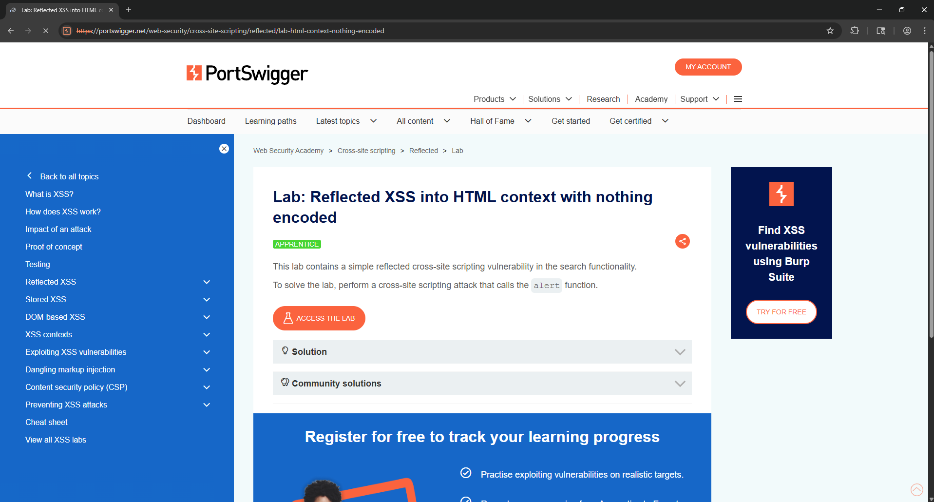
Answer: This configuration allows Burp Suite to act as a man-in-the-middle proxy between my browser and the internet.

Step 4: Capture a Request
Load the lab page in the browser, type "test" into the search bar, and click search.
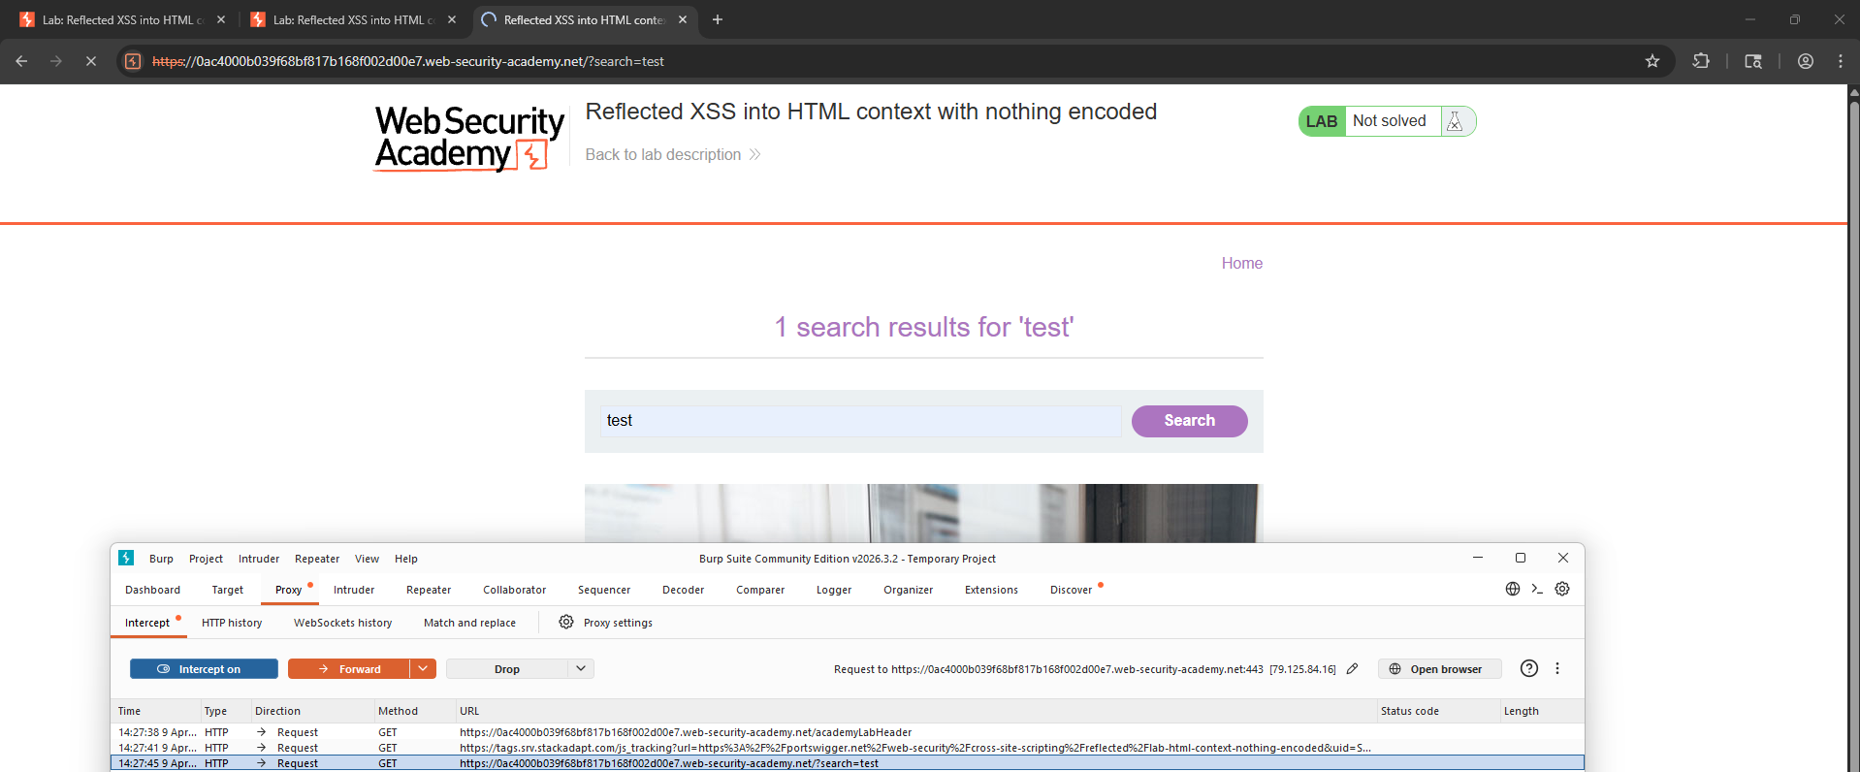
Answer: Burp Suite successfully intercepted the GET request. I right-clicked the request and selected "Send to Repeater" to begin manipulating the parameters.

Step 5: Send To Repeater
Navigate to the Repeater tab to view the raw request and response side-by-side.
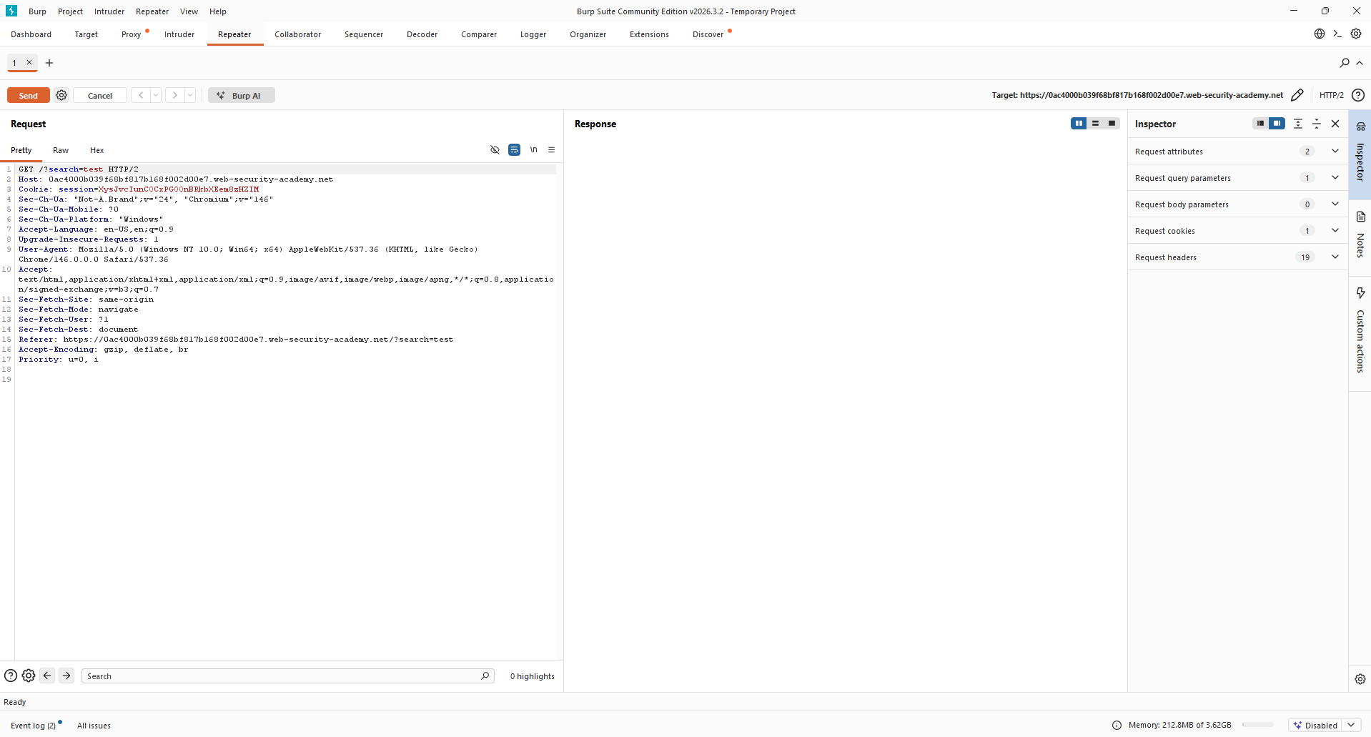
Answer: The Repeater tool allows me to modify the request and see the server's response immediately without having to refresh the browser constantly.

Step 6: Inject XSS Payload
Replace search=test with the payload search=<script>alert(1)</script>.
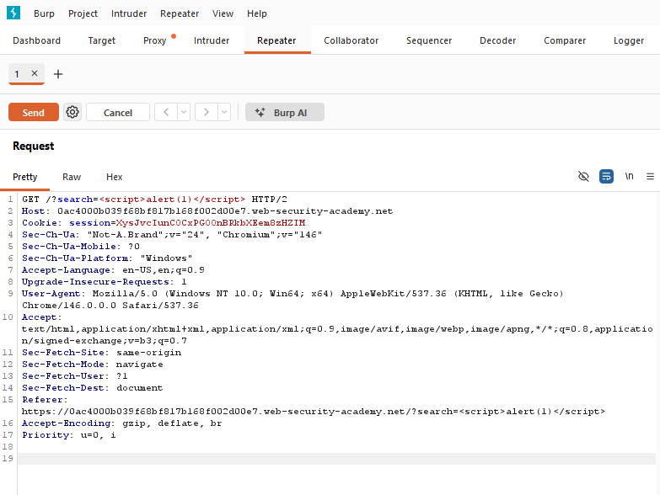
Answer: By injecting <script>alert(1)</script>, I am testing if the server will execute JavaScript code that is passed through a URL parameter.

Step 7: Send Modified Request
Click "Send" in Repeater and check the Response panel for the script.
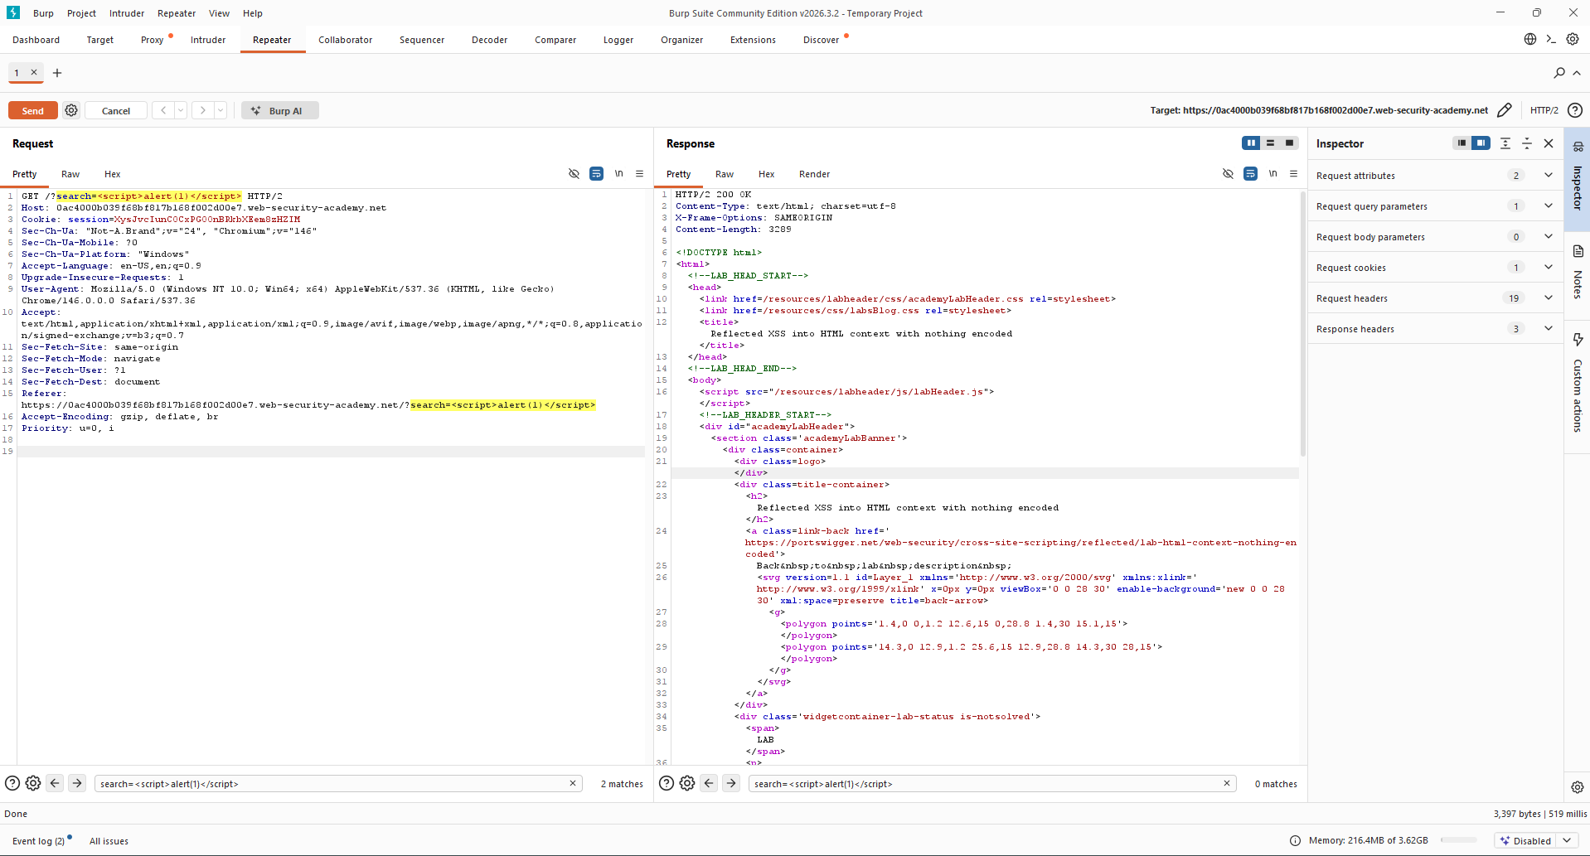
Notes: The modified request containing the payload <script>alert(1)</script> was sent using Burp Suite Repeater. The response shows the payload reflected directly into the HTML without encoding, indicating a potential Cross-Site Scripting (XSS) vulnerability.

Step 9: Execute Attack in Browser
Return to the browser and submit the payload in the search bar to trigger the alert box.
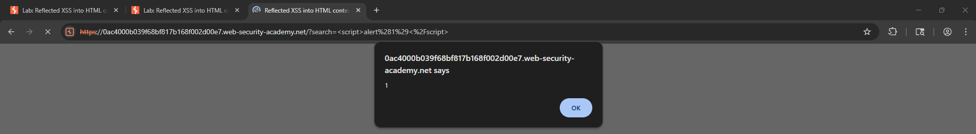
Answer: The browser executed the script, triggering a JavaScript alert box with the value "1".

Step 10: Confirm Lab Solved
Verify that the lab has been officially recorded as solved.
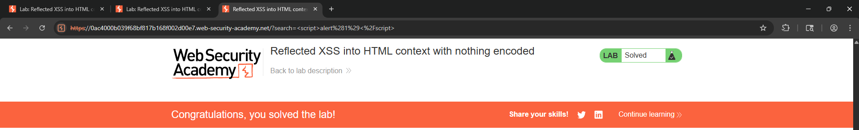
Answer: The appearance of the "Congratulations, you solved the lab!" banner confirms the successful execution of the Reflected XSS attack using Burp Suite.
The work asked in this lab is for educational purposes only and no liability is accepted for abuse.

